Troubleshooting: Windows 11 SQL Server Installation Error
Question:
When I install SQL Server on Windows 11, there is an error message:
Wait on the Database Engine recovery handle failed. Check the SQL Server error log for potential cause.
After I click ‘OK’ on the error, the installation is completed with Database Engine Services and SQL Server Replication failures. The SQL Server Service will not start. Why?

Possible Reason:
On Windows 11 systems, some storage devices and device drivers will expose a disk sector size larger than 4 KB. In this case, the SQL Server will be unable to start as SQL Server currently supports sector storage sizes of 512 bytes and 4 KB.
Solution:
- Uninstall/Remove all the existing SQL Server.

- Add a registry key to force the disk sector size to 4 KB.
Run the Command Prompt as Administrator > Copy and Paste the query below > Press Enter
REG ADD "HKLM\SYSTEM\CurrentControlSet\Services\stornvme\Parameters\Device" /v "ForcedPhysicalSectorSizeInBytes" /t REG_MULTI_SZ /d "* 4095" /f
- Restart the PC.

- Reinstall the SQL Server. It is recommended to install SQL Server 2016 and above.
To download Microsoft SQL Server 2019 Express edition, please click the following link:
Microsoft SQL Server 2019 Express Edition
- Under the Server Configuration page, make sure the Startup Type for SQL Server Database Engine is Manual or Disabled.
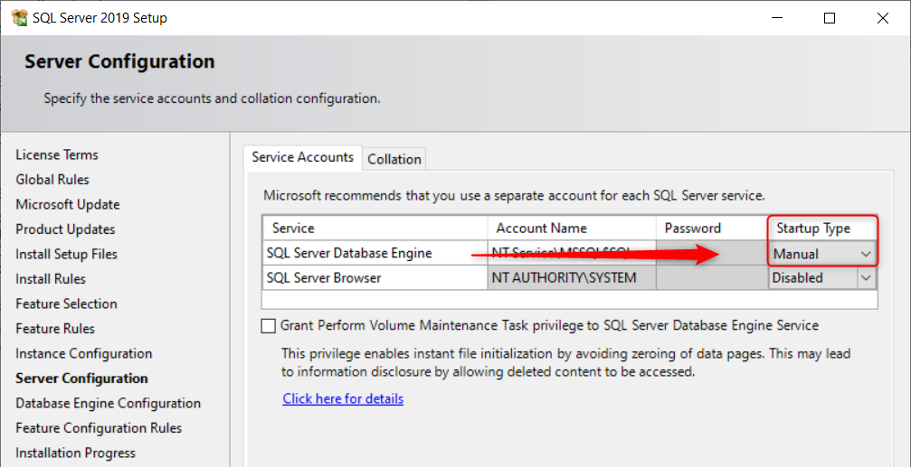
- The installation should be working fine now.

- After that, go to Windows Start > type Services > click on Windows Services.msc

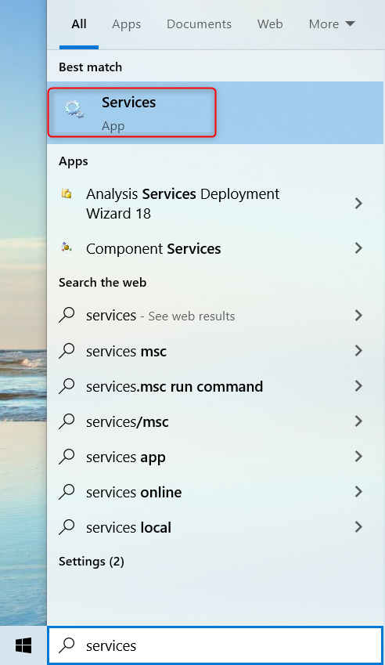

- Right Click SQL Server Service > Properties > Change the Startup Type back to Automatic
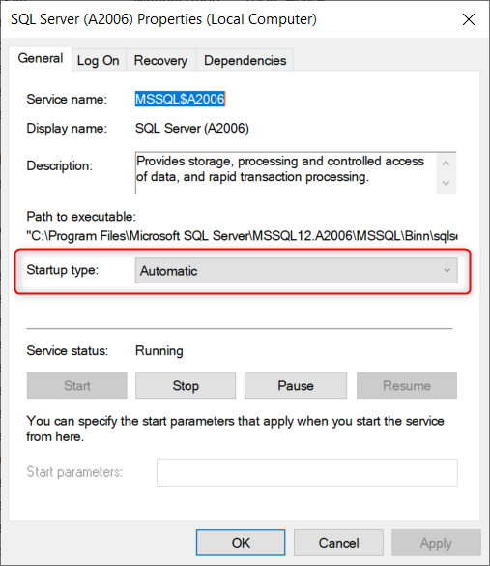
Note: Please contact your software dealer if the problem still persists.

